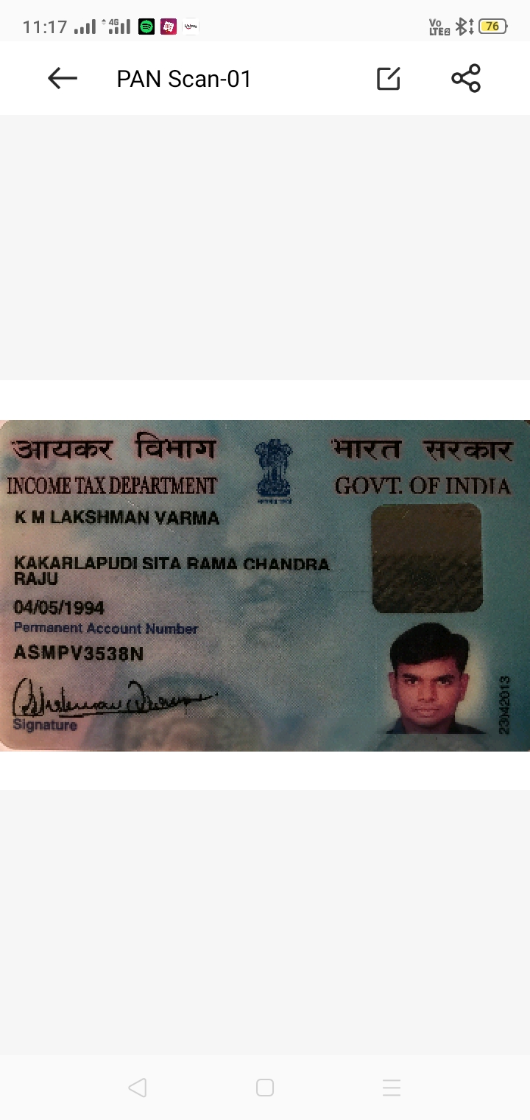

Candidate's Full Legal Name (as it appears on PAN)Vishal Nikam | K M Lakshman Varma
Supplier Name (Registered Name) | People-prime Worlwide
Worked for CG previously? (IF yes share CG  Employee ID/GGID required | No
JOB Posting IDCGEMJP00346815 | CGEMJP00346815
Contact No (10 Digit No) | 9963833399
Email ID | kakarlapudi94@gmail.com
Job Location (Work Location) | Bangalore
Notice Period (Immediate/ Notice to Serve) | Immediate Joiner
Highest Education (Regular or Distance) | PGDM
Employment Detail – Last 2 yrs Working period  (Payroll Company) | Teksystems
College & University Full Name -Biju Pat t naik University T echnology
Mandatory Skills & Experience  (quick checklist – verify each skill, years of  experience) | SAP CRM – 8 Years
“Secondary” Skills & Experience | QTC, Middleware – 8 Years
Key Remarks (Supplier Comment) | Candidate Good at Communication Skill. He has relevant experience of 8 years.

SAP CRM Functional Consultant

Name: Maruthi Kakarlapudi Lakshman Varma
Email: maruthi.kakarlapudi94@gmail.com Mobile: +91 9963833399

SAP CRM Functional Consultant Professional Summary
SAP CRM Functional Consultant with 8 years of experience in SAP CRM 7.0 across implementation, enhancement, support, and maintenance projects. Experience in one end-to-end implementation with expertise in SAP CRM Sales, Service, Marketing, Base Customization, and Web UI configuration. Experienced in gathering business requirements, configuring CRM solutions, supporting customer engagement processes, conducting testing, collaborating with cross-functional teams, and integrating SAP CRM with ECC/SAP business processes. Strong knowledge of CRM Middleware, data migration, functional documentation, and end-user support.

Professional Experience
SAP CRM Functional Consultant TEKSYSTEMS
Project Type: Maintenance & Enhancement
Client: Volvo Group Duration: Sept’23 – Jun’26 Key Responsibilities
- Provided functional support for SAP CRM Sales ensuring business continuity and timely issue resolution within SLA commitments.
- Collaborated with business stakeholders to understand business requirements, analyse customer interaction processes, and prepare functional specifications.
- Worked on functional enhancements related to Export processes, including custom shipment and billing functionalities.
- Coordinated with ABAP technical teams for debugging, enhancements, and implementation of functional solutions.
- Performed Unit Testing, Integration Testing, and User Acceptance Testing (UAT) for change requests and system enhancements.
- Developed test scenarios and validated CRM business processes before production deployment.
- Monitored SAP CRM Middleware, BDOCs, queues, and interface processing to ensure seamless synchronization between SAP CRM and ECC.
- Supported integration activities between SAP CRM and ECC modules, ensuring data consistency and smooth business operations.

- Prepared Root Cause Analysis (RCA), functional documentation, knowledge transfer materials, and user support documents.
- Assisted end users during issue resolution, provided production support, and participated in change management activities using ServiceNow.

SAP CRM Functional Consultant FAUXIQ
Project Type: Implementation & Support
Client: IFB Industries Duration: Jun’18 – Aug’23 Key Responsibilities
- Participated in one full lifecycle SAP CRM implementation including business requirement gathering, solution design, configuration, testing, deployment, and post-go-live support.
- Conducted workshops with business users to understand CRM business processes and translate functional requirements into SAP CRM solutions.
- Configured SAP CRM Web UI components including Business Roles, Navigation Bar Profiles, Logical Links, Work Centers, and Link Groups.
- Configured Business Partner, Partner Determination, Status Profiles, Text Determination Procedures, Action Profiles, Organizational Data Determination, and Date Profiles.
- Customized Business Partner roles, relationships, transaction types, Activities, Leads, Opportunities, and Campaign Management processes.
- Worked extensively on SAP CRM Marketing including Campaign Management, Segmentation, and External List Management.
- Configured and maintained ERMS and Mail Forms for customer service operations.
- Participated in Data Migration and Data Conversion activities from legacy systems into SAP CRM.
- Managed Product Master, Organizational Structures, Installed Base, Equipment, and other master data configurations.
- Supported Equipment replication between ECC and CRM through Middleware.
- Performed Middleware monitoring, BDOC analysis, Queue monitoring, Initial Loads, and Request Loads.
- Coordinated with functional and technical teams to resolve interface issues between SAP CRM and SAP ECC modules (SD, MM, and FI), ensuring smooth integration and consistent business process execution.
- Participated in defect tracking meetings and coordinated issue resolution across functional and technical teams.
- Developed functional specifications, testing documents, and user acceptance testing scripts.
- Conducted Unit Testing, Integration Testing, and UAT while supporting business users during validation.
- Prepared user documentation and knowledge transfer materials for support teams and end users.
- Assisted users during post-go-live support by troubleshooting CRM functional issues and recommending process improvements.

Core Competencies:
- SAP CRM 7.0 & EHP3
- SAP CRM Sales, Service & Marketing
- SAP CRM Web UI Configuration
- SAP CRM Base Customization
- Business Partner Configuration
- Organizational Data Determination
- Product Master Configuration
- Partner Determination
- Activities, Leads & Opportunity Management
- Campaign Management & Segmentation
- ERMS & Mail Forms
- Service Contracts & Service Orders
- Requirement Gathering & Analysis
- User Acceptance Testing (UAT)
- Integration Testing
- SAP CRM–ECC Integration
- Functional Documentation
- Customer Engagement Process Support

Technical Skills:
Category Skills
SAP Versions SAP CRM 7.0 EHP1, EHP3
SAP Modules CRM Sales, Service, Marketing SAP Integration CRM Middleware, ECC Integration
Tools JIRA, ServiceNow (SNOW), Azure, DFS, GLOPPS, Parma Productivity Tools MS Office Suite

Academic Qualifications:
- PGDM in Marketing | 2016 – 2018
- Bachelor of Commerce (B.Com) | 2011 – 2015

Additional Highlights
- Around 8 years of SAP CRM Functional Consulting experience.
- Experience in one complete SAP CRM implementation and multiple enhancement/support engagements.
- Strong expertise in SAP CRM Sales, Service, Marketing, Web UI, Middleware, and Base Customization.
- Experience in requirement gathering, business process analysis, CRM solution configuration, testing, and production support.
- Skilled in developing functional specifications, test scenarios, user documentation, and knowledge transfer materials.
- Experience collaborating with business stakeholders and technical teams to deliver CRM enhancements.
- Hands-on experience in CRM Middleware, data migration, integration testing, UAT, and interface monitoring.
- Excellent communication, analytical, documentation, and stakeholder management skills.
- Experienced in onsite-offshore delivery models and Agile support environments.

